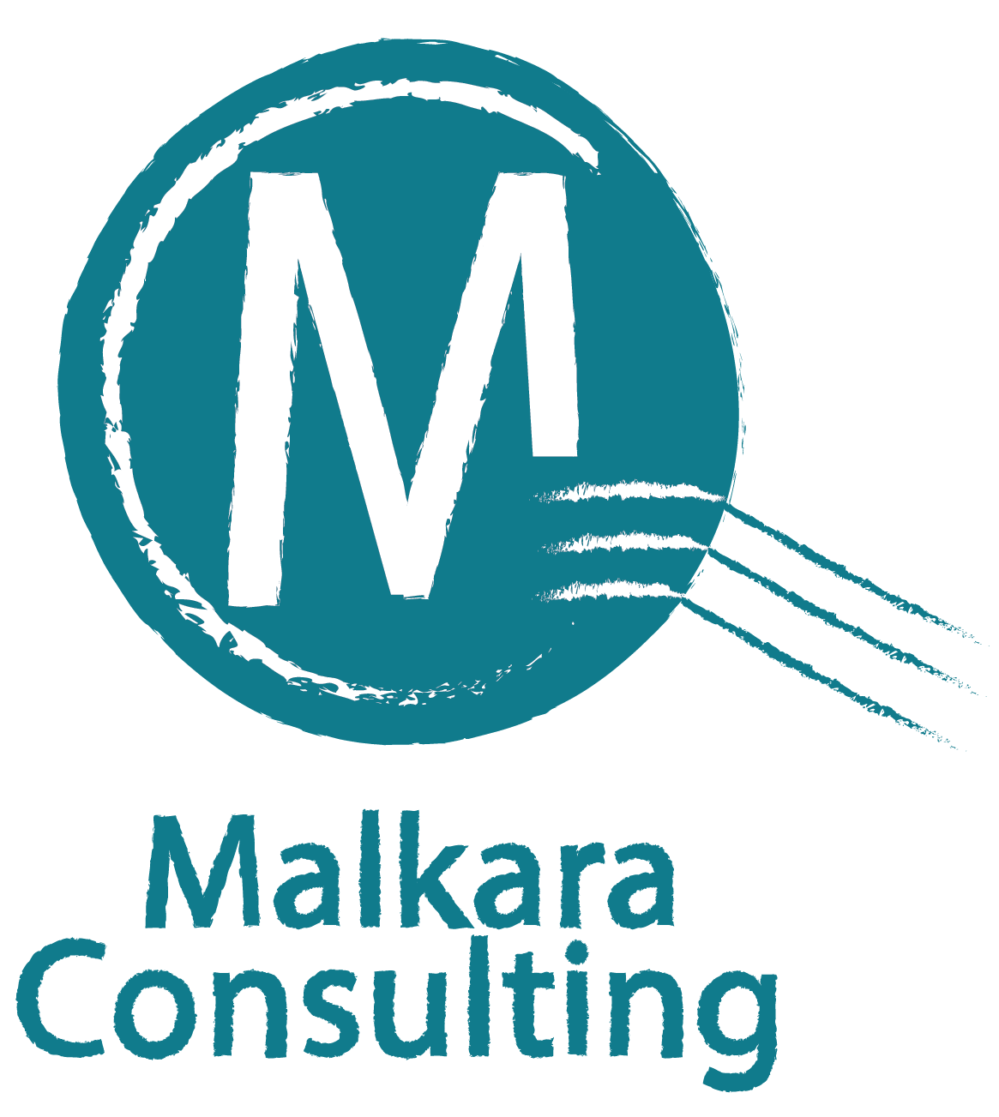

Anti-Bribery & Corruption

(Government) Workshop

27 to 29 November 2018

This proposal including its title and contents are owned by Malkara Consulting. No part of this proposal is to be used or communicated outside of the intended recipients without the express authority of Malkara Consulting.

Introduction
Corruption can have a major impact on a country, an organisation and an individual because it affects economic growth and the accumulation of wealth. It can weaken institutions and people and if left unchecked can threaten a government. Consequences of corruption for a government are diverse and can include damage to reputation, loss of confidence by taxpayers, risk of lawsuits from aggrieved suppliers/contractors and dismissal of management and elected officials.
But the most severe consequence could arise for managers and employees. Any act of corruption tarnishes their reputation whether they were involved or not. An organisation would be hesitant to employ any former government chief executive officer, manager or employee out of fear it could be onboarding a future corruption problem. And foreign governments would be reluctant to issue a visa for any person involved in a corruption scandal.
Unfortunately, many government departments or authorities do not appropriately assess the risk corruption poses to them or if they have undertaken an initial assessment, do not update it when there are changes to key positions or when large costly projects are being considered.

Effectiveness is Our Focus

Malkara Consulting understands corruption risk. We design training workshops which focus on improving effectiveness. Effectiveness is the extent to which an organisation mitigates the risks and threats of corruption. As a consultancy firm, Malkara Consulting assesses effectiveness using a fundamentally different approach to assessing technical compliance with relevant laws. It does not involve a box ticking exercise which checks to ascertain if specific requirements are met. In assessing effectiveness, Malkara Consulting examines if the anti-bribery and corruption compliance system of an organisation is working.

In relation to our training workshops, technical compliance is incorporated into the training framework and material. Corruption risk is incorporated into specific areas relevant to an organisation’s business or operations. In relation to government, it includes elected officials; the services offered; suppliers it deals with; managers, employees and contractors; its geographical location; industry groups and companies.

Anti-Bribery & Corruption Workshop

The risk to any organisation of being caught in a corruption scandal is ever present regardless of the environment it operates in, interacts with or the standard of its corporate governance.

The Anti-Bribery and Corruption (Government) Workshop offered by Malkara Consulting have been designed to meet the needs of managers and employees working in government including:

Elected representatives

Senior managers and executives including the Chief Executive Officer

Any organisations contracted to perform services on behalf of a government

Government employees

The ABC Workshop conducted by Malkara Consulting focuses on people, the weakest link in any ABC Risk Management Plan. Each workshop will address how managers, employees, contractors and third parties representing the government can be corrupted. Knowledge of corruption methods will enable government departments and authorities that undertake the training, to build and implement more effective ABC measures.

Personal Pledges to Combat Corruption

The capstone of each workshop is the requirement that participants affirm and sign a personal pledge committing themselves and the organisation they lead, work for or contracted to, in combating bribery and corruption in their organisation, country and globally. Participants will be encouraged to display their pledge on websites, internal bulletins and personal correspondence (e.g. inserted in a prominent position on letters and emails or under a signature block). These personal pledges are an effective means to build the image of government, protect the reputation of individuals and act as a deterrent against corruption.

Anti-Bribery & Corruption (Government) Workshop
27 to 29 November 2018 Perth, Western Australia
Timetable

Time | Tuesday, 27 November | Wednesday. 28 November | Thursday, 29 November
0900 - 1015 | Introductions & Overview of Workshop  Introduction to Corruption | Introduction to ISO37001 Anti-Bribery Management Systems | Reporting Corruption  (Whistleblowing)
1015-1030 | Morning Tea | Morning Tea | Morning Tea
1030 - 1200 | Introduction to Corruption continued  The Corruption Process | Employing Staff & Third-Party Due Diligence | Corruption & Bribery Techniques
1200 - 1300 | Lunch | Lunch | Lunch
1300 - 1430 | Culture & Corruption | Corruption Risk (Procurement) | Corruption & Bribery Techniques
1430 - 1450 | Afternoon Tea | Afternoon Tea | Afternoon Tea
1450 - 1630  1630 | Anti-Bribery & Corruption Compliance Programme  Close | Corruption Risk (Disposal of Public Property & Goods)  Close | How Leaders Make a Difference  Personal Pledges  Close

Subject Descriptions

Anti-Bribery and Corruption Compliance Programme: An anti-bribery and corruption compliance programme is the bedrock of preventing corruption. The title of the unit is consistent with international terminology however the subject, aims to assist organisations to be more effective in the prevention, reporting and dealing with bribery and corruption. This topic will explore how an organisation can implement, to the extent possible, systems that aim to be effective in identifying, preventing and reporting corruption. All other subjects in the workshops have their grounding and are linked to this unit.
Corruption Process: This unit contains an explanation of the corruption process with an emphasis on the use by criminals of target identification, the softening up process (“grooming”) and the impact of corrupt employees; managers and contractors working for an organisation.
Corruption & Bribery Techniques: This unit will explain the various methods used to make and hide a corrupt payment including the use of financial institutions, nominees, commodities and services and corporations.
Corruption Risk (Procurement): This subject examines the corruption risks associated with the procurement by government departments and authorities when procuring goods and services and suggests measures to reduce the risk of corruption occurring.
Corruption Risk (Disposal of Public Property & Goods): This subject examines the corruption risks associated with the disposal of public property and goods by government departments and authorities and outlines measures to reduce the risks involved.
Culture and Corruption: The meaning and importance of an organisation developing an ethical culture is explained, of leaders setting the right tone, drivers of an ethical culture and why rewards need to be tied to the values of the organisation.
Employing Staff & Third Party Due Diligence: People are the greatest risk to an anti-bribery and corruption programme. Bribery and corruption risk can be substantially reduced if appropriate measures, implemented in line with the risks identified, are taken to employ and train staff in anti-bribery and corruption including the core values and code of conduct of an organisation. Third parties, for example contractors representing an organisation and suppliers of goods or services to an organisation, pose a significant corruption risk. This unit will explore third party bribery and corruption risks and outline a framework to reduce the risks via the appropriate vetting of employees, managers, contractors and suppliers before they are engaged.
How Leaders Make a Difference. An open session discussion lead by the workshop facilitators, who will share their experience in working in corrupt environments or in corrupt organisations or who have handled corruption issues and the importance of the right culture and leadership in combating corruption.
Introduction to ISO 37001 Anti-Bribery Management Systems. Introduced in October 2016 by the International Organisation for Standardization (ISO), ISO 37001 is designed to assist organisations to detect, prevent and respond to bribery. This subject, will briefly outline the requirements that an organisation must meet to be certified as complying with the standard and the benefits of compliance.
Introduction to Bribery & Corruption: Corruption can undermine any organisation and cause serious financial loss and damage to their reputation. This unit explains the building blocks to corruption, namely illegal gratuities and conflicts of interest, what corruption and bribery are, causes of corruption, impact of corruption and the recycling of corrupt managers and staff.
Personal Pledges to Combat Bribery & Corruption: The capstone of each workshop is the requirement that participants affirm and sign a personal pledge committing themselves and the organisation they lead, work for or contracted to, to combating bribery and corruption in their organisation, country and globally. Participants will be encouraged to display their pledge on websites, internal bulletins and personal correspondence (e.g. inserted in a prominent position on letters and emails or under a signature block). These personal pledges are an effective means to build the brand of an organisation, the reputation of individuals and act as a deterrent against corruption.
Reporting Corruption (Whistleblowing): A cornerstone in the prevention of bribery and corruption is an effective whistleblowing policy of the organisation. How a government department or authority encourages managers, employees and external stakeholders such as contractors and the public to report corruption is a window into the values of elected officials and managers. All stakeholders should be able to report corruption confidentially and free from recriminations. This policy should be known to all managers, employees, third party agents and contractors but often it is not. Today the public, governments, investors and lenders and potential employees are looking for greater transparency from organisations. With an effective and encouraged whistle blower policy, stakeholders will have strengthened confidence in government; that it is well managed with a set of strong ethical values.

